Model Exam
MLA0214 – Fundamentals of Machine Learning for Motlbot
Name: Siva Dakshitha Reg no:192425395

Experiment-1(NAÏVE BAYES)

Aim
To classify emails as spam or not using Naïve Bayes based on Offer and Link features.
Algorithm
- Calculate prior probabilities:
  - P(Spam), P(Not Spam)
- Calculate conditional probabilities:
  - P(Offer | Spam), P(Link | Spam)
- Apply formula:
$$P(Spam∣X)∝P(Spam)×P(Offer∣Spam)×P(Link∣Spam)$$
- Compare probabilities and classify.

Code

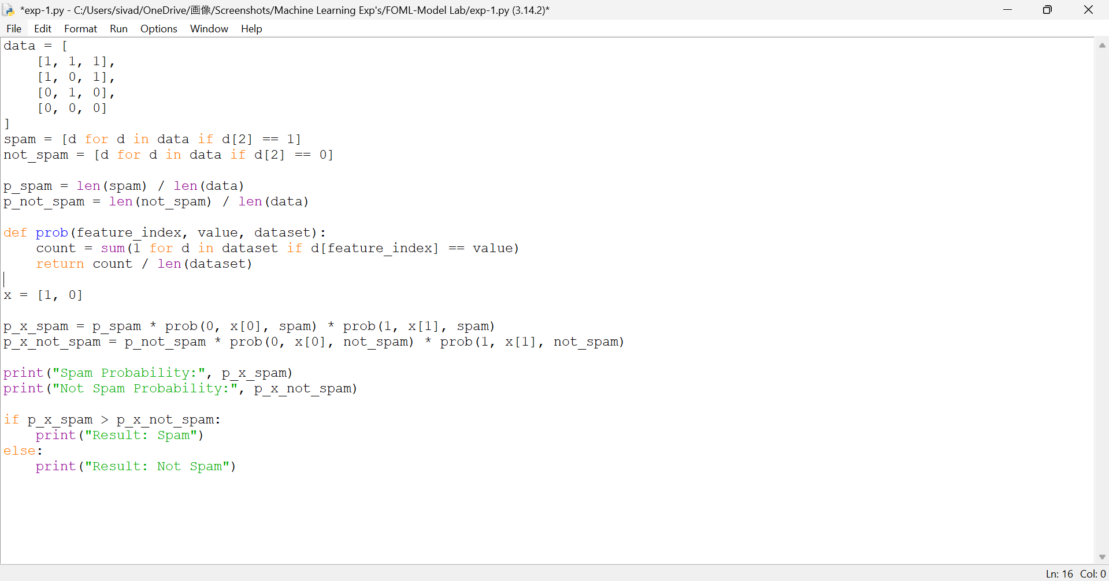

Output

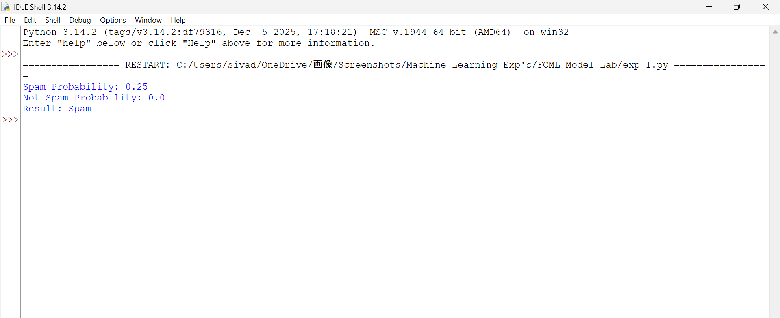

Result
Naïve Bayes algorithm was successfully implemented and the spam email classification was performed successfully.

